**Forcast Content Writing Assignment**

By-Naina Sahu

Date-25 July 2023

**Assignment 1. Supervised Learning**

**Introduction:**

Supervised learning, also known as supervised machine learning, is a subcategory of [machine learning](https://www.ibm.com/topics/machine-learning) and [artificial intelligence](https://www.ibm.com/topics/artificial-intelligence). It is defined by its use of labeled datasets to train algorithms that to classify data or predict outcomes accurately. As input data is fed into the model, it adjusts its weights until the model has been fitted appropriately, which occurs as part of the cross validation process. Supervised learning helps organizations solve for a variety of real-world problems at scale, such as classifying spam in a separate folder from your inbox.

Steps Involved in Supervised Learning:

* First Determine the type of training dataset
* Collect/Gather the labelled training data.
* Split the training dataset into training dataset, test dataset, and validation dataset.
* Determine the input features of the training dataset, which should have enough knowledge so that the model can accurately predict the output.
* Determine the suitable algorithm for the model, such as support vector machine, decision tree, etc.
* Execute the algorithm on the training dataset. Sometimes we need validation sets as the control parameters, which are the subset of training datasets.
* Evaluate the accuracy of the model by providing the test set. If the model predicts the correct output, which means our model is accurate.

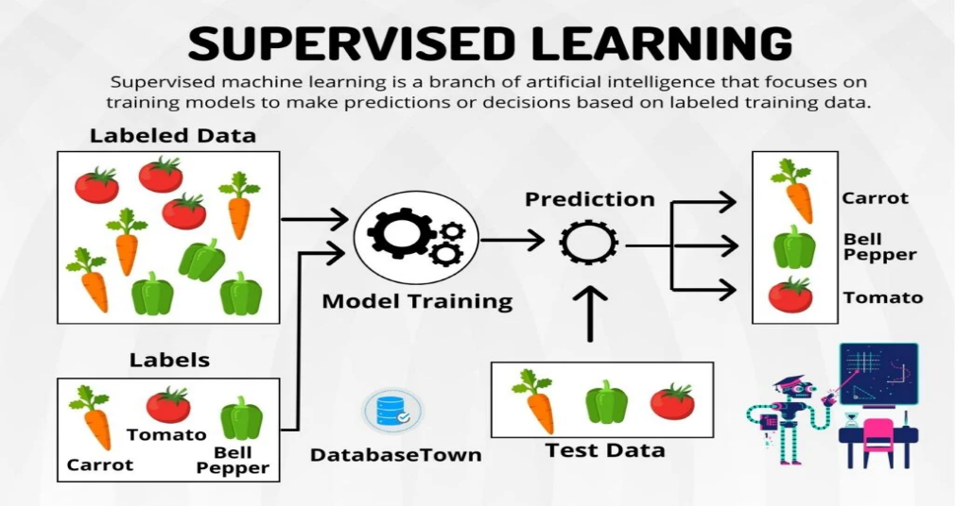

## Types of supervised Machine learning Algorithms:

Supervised learning can be further divided into two types:

**1. Regression**

Regression algorithms are used if there is a relationship between the input variable and the output variable. It is used for the prediction of continuous variables, such as Weather forecasting, Market Trends, etc. Below are some popular Regression algorithms which come under supervised learning:

* Linear Regression
* Regression Trees
* Non-Linear Regression
* Bayesian Linear Regression
* Polynomial Regression

**2. Classification**

Classification algorithms are used when the output variable is categorical, which means there are two classes such as Yes-No, Male-Female, True-false, etc.

Spam Filtering,

* Random Forest
* Decision Trees
* Logistic Regression
* Support vector Machines

Q1. Bias -Variance Tradeoff:

Machine learning is a branch of Artificial Intelligence, which allows machines to perform data analysis and make predictions. However, if the machine learning model is not accurate, it can make predictions errors, and these prediction errors are usually known as Bias and Variance. In machine learning, these errors will always be present as there is always a slight difference between the model predictions and actual predictions. The main aim is to reduce these errors in order to get more accurate results.



## Bias-Variance Trade-Off

The bias-variance trade-off is a fundamental concept in machine learning that deals with the relationship between the bias of a model and its variance. It refers to the delicate balance between the model's ability to capture the true underlying patterns in the data (low bias) and its sensitivity to fluctuations or noise in the training data (high variance).

1.Bias:

•Bias measures how far off the predictions of a model are from the true values.

•A high bias indicates that the model makes strong assumptions about the data, leading to simplified representations.

•Models with high bias tend to underfit the data, i.e., they fail to capture the underlying patterns.

2.Variance:

•Variance refers to the variability of model predictions for different training datasets.

•High variance implies that the model is overly sensitive to fluctuations or noise in the training data.

•Models with high variance tend to overfit the data, i.e., they capture noise or random fluctuations instead of the underlying patterns.

3Trade-off:

•The bias-variance trade-off suggests that decreasing bias often leads to an increase in variance and vice versa.

•A simple model with high bias may have low variance since it makes strong assumptions and generalizes similarly across different datasets.

•In contrast, a complex model with low bias may have high variance because it can capture more intricate patterns but is prone to overfitting and varies significantly across datasets.

The goal in machine learning is to strike a balance between bias and variance to achieve good generalization performance on unseen data. This is typically done through techniques such as model selection, hyperparameter tuning, regularization, and cross-validation. The optimal trade-off depends on the specific problem, the available data, and the desired level of model complexity. It often involves iterative experimentation and evaluation to find the right balance that minimizes the overall error on unseen data.

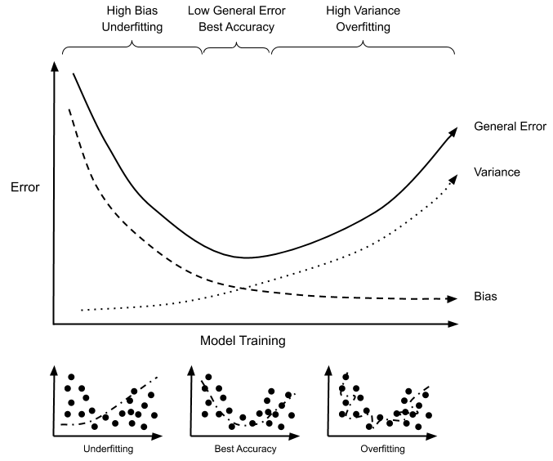

Q2. SVM Intution of Kernels and RBF Kernal Working

**Introduction**

Support Vector Machines (SVM) is a powerful and versatile machine learning algorithm used for classification and regression tasks. SVMs are particularly effective in solving complex problems with high-dimensional feature spaces. They are based on the principles of structural risk minimization and the concept of finding an optimal hyperplane that best separates different classes of data.

Here's an introduction to the key components and concepts of SVM:

1. Hyperplane:
   * In SVM, a hyperplane is a decision boundary that separates the data points into different classes.
   * In a binary classification problem, the hyperplane aims to maximize the margin, which is the distance between the hyperplane and the closest data points of each class.
   * SVMs can handle linearly separable data by finding the hyperplane that maximizes the margin.
2. Support Vectors:
   * Support vectors are the data points closest to the hyperplane, influencing its position and orientation.
   * These points play a crucial role in determining the optimal hyperplane and class separation.
   * SVMs are named after these support vectors, as they are the critical elements of the algorithm.
3. Kernel Functions:
   * SVMs can handle nonlinearly separable data by mapping it to a higher-dimensional feature space.
   * Kernel functions enable this mapping, transforming the data into a space where linear separation becomes possible.
   * Commonly used kernel functions include linear, polynomial, radial basis function (RBF), and sigmoid.
   * Choosing the appropriate kernel function depends on the problem and the data characteristics.
4. Soft Margin:
   * In real-world scenarios, data is often not perfectly separable by a hyperplane.
   * SVMs can handle such cases by allowing a certain amount of misclassification or overlap.
   * The concept of a soft margin involves introducing a penalty for misclassifying data points or allowing them to be within the margin region.
5. C Parameter:
   * The C parameter controls the trade-off between maximizing the margin and minimizing the misclassification or overlap.
   * A smaller C value encourages a wider margin but allows more misclassifications.
   * A larger C value focuses on correctly classifying as many points as possible, potentially resulting in a narrower margin.

SVMs have been widely used in various applications, including image recognition, text categorization, bioinformatics, and finance. They are known for their ability to handle high-dimensional data and their robustness in dealing with complex decision boundaries. With proper kernel selection and parameter tuning, SVMs can effectively solve challenging classification and regression problems.

# **Support Vector Machine Algorithm**

The Support Vector Machine (SVM) algorithm is a popular supervised learning algorithm used for both classification and regression tasks. It is particularly effective in solving complex problems with high-dimensional feature spaces. The algorithm aims to find an optimal hyperplane that separates data points of different classes or predicts continuous values for regression.

Here are the main steps involved in the SVM algorithm:

1. Data Preprocessing:
   * SVM requires labeled training data, where each data point is associated with a specific class or a target value for regression.
   * The data is typically represented as feature vectors, where each feature represents a characteristic or attribute of the data point.
   * It is important to scale or normalize the features to ensure they are on a similar scale and prevent any bias in the learning process.
2. Hyperplane Selection:
   * SVM seeks to find the optimal hyperplane that maximizes the margin, which is the distance between the hyperplane and the closest data points of each class.
   * The hyperplane effectively separates the data points into different classes or predicts continuous values for regression.
   * In the case of linearly separable data, a hyperplane can be found that completely separates the classes. For nonlinear data, SVM employs kernel functions to transform the data into a higher-dimensional feature space where linear separation is possible.
3. Margin Maximization:
   * SVM aims to find the hyperplane with the largest margin to achieve good generalization on unseen data.
   * The margin is the region between the hyperplane and the closest data points of each class.
   * SVM seeks to maximize this margin to provide a larger separation between classes, improving the algorithm's ability to generalize and classify or predict accurately on new data.
4. Support Vectors:
   * Support vectors are the data points that lie closest to the hyperplane and influence its position and orientation.
   * These support vectors are crucial in determining the optimal hyperplane and separating different classes.
   * SVM focuses on these support vectors rather than the entire dataset, making the algorithm memory-efficient.
5. Soft Margin and Regularization:
   * In real-world scenarios, data is often not perfectly separable by a hyperplane.
   * SVM allows for a certain amount of misclassification or overlap by introducing a soft margin.
   * The C parameter controls the trade-off between maximizing the margin and allowing misclassifications. A smaller C value allows more misclassifications, while a larger C value enforces a smaller margin and focuses on correct classification.
6. Prediction:
   * Once the optimal hyperplane is determined, SVM can classify new, unseen data points or predict continuous values for regression.
   * For classification, a new data point is assigned to a class based on which side of the hyperplane it falls.
   * For regression, the position of the data point relative to the hyperplane determines its predicted value.

The SVM algorithm is known for its ability to handle high-dimensional data, capture complex decision boundaries, and generalize well to unseen data. It has found applications in various domains, including image recognition, text classification, bioinformatics, and financial analysis.



SVM algorithm can be used for **Face detection, image classification, text categorization,**etc.

**Types of SVM:**

1. Linear SVM:
   * Linear SVM uses a linear kernel to find a linear decision boundary that separates the data into different classes.
   * It is suitable for problems where the data can be effectively separated by a straight line or hyperplane.
   * Linear SVM is computationally efficient and works well with large datasets.
2. Nonlinear SVM:
   * Nonlinear SVM incorporates kernel functions to map the input data into a higher-dimensional feature space.
   * It enables the SVM to capture nonlinear relationships and find complex decision boundaries.
   * Common kernel functions used in nonlinear SVM include polynomial, radial basis function (RBF), and sigmoid.
3. Support Vector Classification (SVC):
   * SVC is an SVM variant specifically designed for classification tasks.
   * It seeks to find the optimal hyperplane that maximizes the margin between classes while allowing for a certain margin of error or misclassifications.
   * SVC is suitable for binary classification as well as multi-class classification problems.
4. Support Vector Regression (SVR):
   * SVR is an extension of SVM for regression tasks.
   * It aims to find a regression function that fits the data while limiting deviations within a certain margin.
   * SVR allows for a margin of tolerance for errors, with an epsilon-tube defined around the regression function.
   * SVR is used to predict continuous values rather than discrete class labels.

These are some of the commonly known types of SVMs. Each type has its specific characteristics, strengths, and applications. The choice of SVM type depends on the nature of the problem, the data, and the desired complexity of the model.

**Intuitive explanation of kernels in SVMs:**

1. Linearly Inseparable Data: Imagine a dataset where the classes cannot be separated by a straight line (linearly inseparable). In such cases, a linear SVM would fail to find an appropriate decision boundary. Kernels come into play here by transforming the input data into a higher-dimensional space, where it becomes easier to separate the classes.
2. Kernel Trick: The kernel trick is a mathematical technique used by SVMs to implicitly perform the transformation into a higher-dimensional space without explicitly computing it. Instead of directly transforming the data, the kernel function computes the dot products between the transformed data points. This approach avoids the computational burden associated with explicitly working in high-dimensional spaces.
3. Non-Linear Decision Boundaries: Kernels allow SVMs to find non-linear decision boundaries in the transformed feature space. By using different types of kernels, SVMs can capture complex patterns and relationships in the data. Common kernel functions include the Radial Basis Function (RBF), Polynomial, and Sigmoid.
4. RBF Kernel: The Radial Basis Function (RBF) kernel is widely used in SVMs. It maps the data into an infinite-dimensional space using a Gaussian-like function. The RBF kernel is effective in capturing complex, non-linear decision boundaries and is a popular choice when working with SVMs.
5. Kernel Parameters: Kernels often have additional parameters that can be tuned to control the shape and flexibility of the decision boundary. For example, the RBF kernel has a parameter called **gamma** that determines the smoothness of the decision boundary. Adjusting these parameters can significantly impact the performance of the SVM model.

In summary, kernels in SVMs enable the learning algorithm to work in higher-dimensional spaces and find non-linear decision boundaries. They provide a way to handle complex data that cannot be separated by linear methods alone. By transforming the input data using kernels, SVMs can capture intricate patterns and achieve better performance on a wide range of classification and regression problems.

Top of Form

Top of Form

**Radial Basis Function (RBF) kernel and Python examples Radial Basis Function (RBF) kernel and Python examples Top of Form**

**Top of Form**

**Top of Form**

**Radial Basis Function (RBF) kernel and Python examples:**

The Radial Basis Function (RBF) kernel is a popular kernel function used in Support Vector Machines (SVMs) for handling nonlinear data. It transforms the data into a higher-dimensional feature space, allowing SVM to capture complex relationships and find nonlinear decision boundaries. The RBF kernel is defined as:

K(x, y) = exp(-gamma * ||x - y||^2)

Here, gamma is a parameter that determines the influence of each training example and controls the smoothness of the decision boundary. A higher value of gamma leads to a more complex decision boundary that closely fits the training data, potentially resulting in overfitting.

To use the RBF kernel in SVM with Python, you can utilize the scikit-learn library. Here's an example of how to apply SVM with the RBF kernel using scikit-learn:

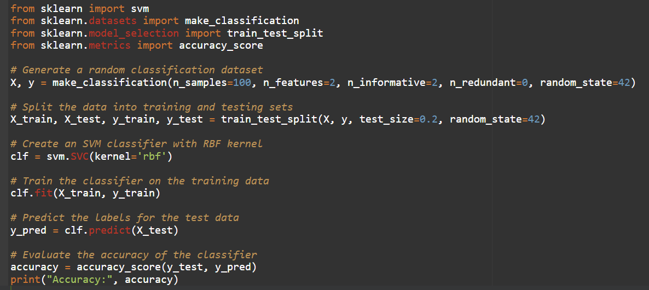

In this example, the RBF kernel is used to create an SVM classifier (**clf**). The classifier is trained on the training data (**X_train**, **y_train**), and the predicted labels for the test data (**X_test**) are obtained using the **predict** method. The accuracy of the classifier is then evaluated using the **accuracy_score** function.

Keep in mind that the RBF kernel has a parameter called **gamma** that determines the smoothness of the decision boundary. By default, **gamma** is set to **'scale'**, which means it is calculated as **1 / (n_features * X.var())**. You can also specify a specific value for **gamma** by setting the parameter explicitly in the **SVC** class.

Note: The code provided here assumes that you have scikit-learn installed and have imported the necessary modules.

. How does GBDT work in regression? How does GBDT work in regression?How does GBDT work in regression?How does GBDT work in regression?Top of Form

**Assignment 2. Python Libraries**

**Q1.** . Explain the multidimensional matrices and their indexing in NumPy in an interactive way.

[NumPy](https://www.geeksforgeeks.org/python-numpy/) is a general-purpose array-processing package. It provides a high-performance multidimensional array object and tools for working with these arrays. It is the fundamental package for scientific computing with [Python](https://www.geeksforgeeks.org/python-programming-language/). It contains various features.

Multidimensional matrices and their indexing in NumPy in an interactive way. Let's start by importing the NumPy library:

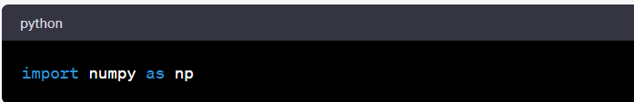

2-dimensional matrix using NumPy. We can use the **np.array()** function to create a matrix from a Python list. For an example:

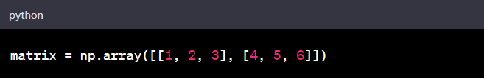

Now we have a 2-dimensional matrix with two rows and three columns:

To access specific elements in the matrix, we can use indexing. In NumPy, indexing starts from 0. We can specify the row and column indices inside square brackets to access a particular element. For example, to access the element in the first row and second column (value 2), we can use the followingg indexing:

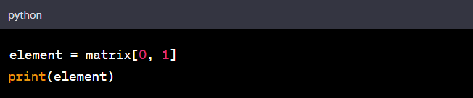

Output:

Similarly, we can access a whole row or column by specifying a single index. For example, to access the second row, we can use:

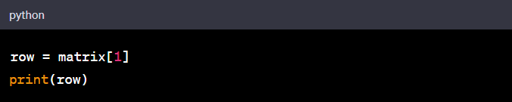

Output:

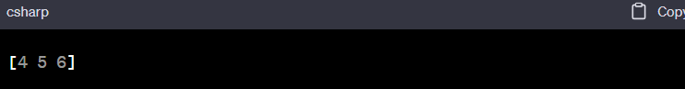

To access a column, we can use the colon **:** to specify all rows and a specific column index. For example, to access the third column, we can use:

Output:

We can also use slicing to extract a subset of the matrix. Slicing allows us to specify a range of indices to select a portion of the matrix. For example, to extract the submatrix consisting of the first two rows and all columns, we can use:

Output:

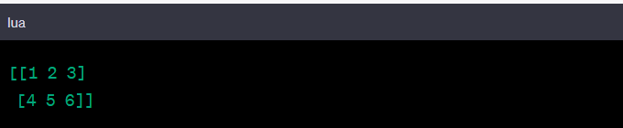

Q2-Explain the use and working of Pivot Table in Panda

A pivot table is a powerful feature in pandas that allows you to summarize and transform data in a flexible and insightful way. It enables you to reshape, aggregate, and analyze data by creating a new table derived from an existing DataFrame.

Here's an explanation of the use and working of pivot tables in pandas:

1. Use of Pivot Tables: Pivot tables are particularly useful when you want to:
   * Summarize data and calculate aggregate statistics (e.g., sum, mean, count) based on specific columns or conditions.
   * Perform cross-tabulation or contingency table analysis.
   * Rearrange and restructure data to gain insights and facilitate analysis.
   * Visualize data and identify patterns or trends.
2. Creating a Pivot Table: To create a pivot table in pandas, you typically start with a DataFrame and use the **pivot_table()** function. This function takes several parameters, including the DataFrame, the index column(s) (used for rows), the column(s) to aggregate (used for columns), and the values to aggregate.

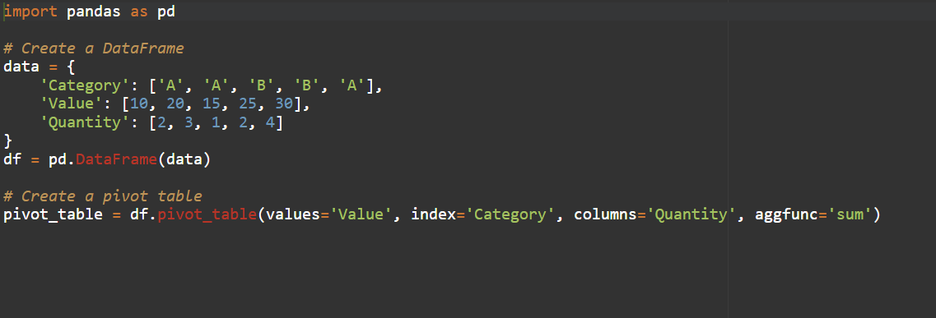

1. Working of Pivot Tables: When you create a pivot table, pandas performs the following steps:
   * Groups the data based on the specified index columns.
   * Forms a grid structure with the unique combinations of the index and column values.
   * Applies the aggregation function to calculate the values in each cell of the grid, which represents the summarized data.
2. Aggregation Functions: Pivot tables allow you to aggregate data using various functions, such as **sum()**, **mean()**, **count()**, **max()**, **min()**, and more. You can specify the aggregation function using the **aggfunc** parameter in the **pivot_table()** function.
3. Handling Missing Values: By default, if there are missing values in the original DataFrame, the pivot table will have NaN (Not a Number) values in the corresponding cells. You can handle missing values by specifying the **fill_value** parameter in the **pivot_table()** function.
4. Multiple Index and Columns: You can create pivot tables with multiple index and column levels by passing a list of column names to the **index** or **columns** parameter.
5. Additional Parameters: The **pivot_table()** function provides additional parameters to further customize the pivot table, such as **margins** for adding row/column totals, **dropna** for excluding rows/columns with missing values, and more.

Once we have created a pivot table, we can access and analyze the summarized data for further exploration, visualization, or reporting.

Pivot tables are a versatile tool in pandas, enabling us to transform and analyze data in a concise and meaningful way. They provide a convenient approach for summarizing and visualizing complex datasets, helping you gain insights and make data-driven decisions.

